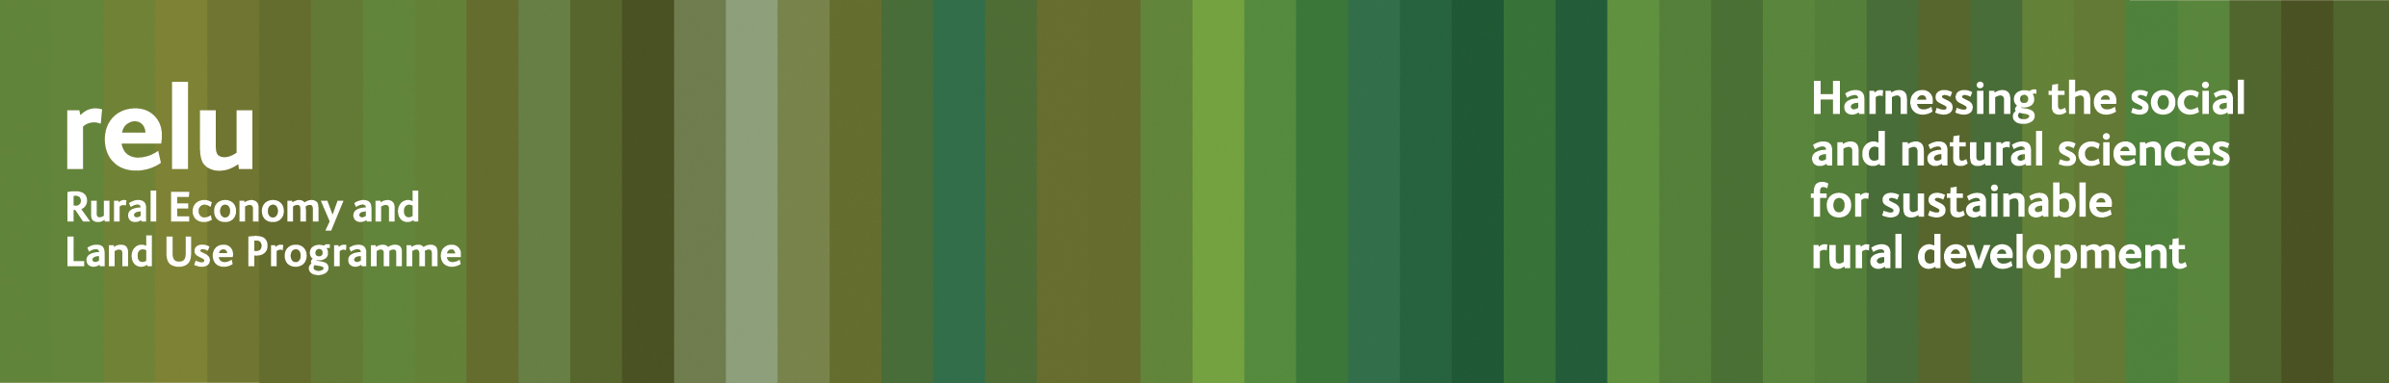
PRESS RELEASE
8 March 2010

What price can we expect rural areas to pay for urban flood control?

Countryside land management could play an increasingly important role in flood planning in the future. But we need to acknowledge the price rural communities may be paying to protect our towns and cities. We have to consider the whole portfolio of services that floodplains provide, and how these are paid for, say scientists at Cranfield University and the Open University.

Research carried out as part of the UK Research Councils’ Rural Economy and Land Use Programme has looked at the effects of the severe summer 2007 floods. Around 42,000 hectares of agricultural land was flooded, at a cost of £50 million. Over 80% of that was caused by crop losses or additional expenditure on items such as animal feed, while the remainder involved damage to property and machinery and the costs of cleaning up after the waters receded. Most agricultural losses were not insured and on average, compensation payments only covered 5% of the costs of damage.

Government strategy is increasingly looking at ways of using floodplains and agricultural land to manage water and protect densely populated areas. This means that we are making more demands on land and requiring it to perform multiple functions, including food production, supporting biodiversity and ensuring the quality of our water supply, as well as floodwater storage.

The Relu team has been investigating these competing demands on rural floodplains and what they might mean for land managers, communities and policymakers. They conclude that there is a need for an integrated approach to policy that takes into account all the ecosystem services provided by the floodplain, and the inevitable trade-offs that must be made.

Professor Joe Morris of Cranfield University who led the research said: “Past policy interventions in floodplains have promoted different objectives at different times – for 50 years we had ‘reclamation and improvement’ for food production, but since the 1990s greater recognition has been given to other ecosystem services, such as biodiversity, and now flood management is rising up the agenda. Increased global demand for food and energy, combined with the prospect of climate change, could reinstate the importance of agricultural production in floodplains, especially as these areas contain almost 60% of our Grade 1 land.

“Balancing these competing demands is challenging - we must look at these land management systems holistically and acknowledge the trade-offs and the costs involved in different options. Specifically we should explore how a range of different benefits from land use can be achieved simultaneously. We need to join up the hitherto fragmented policies and funding mechanisms to support an integrated approach, developing new collaborations between private and public organisations in the process. The forthcoming review of the Common Agricultural Policy provides a great opportunity to explore how best to use our limited land resources, as well as public funds, for maximum overall benefit.”

Notes for editors:

- Further results from the research may be found in Relu’s Policy and Practice Note no 15 http://www.relu.ac.uk/news/policy%20and%20practice%20notes/Morris/Morris.pdf
- The Rural Economy and Land Use Programme is an interdisciplinary collaboration between the Economic and Social Research Council (ESRC), the Biotechnology and Biological Sciences Research Council (BBSRC) and the Natural Environment Research Council (NERC), with additional funding provided by the Scottish Government and Defra. See www.relu.ac.uk for more information about the Relu programme.
- For more information contact Anne Liddon, Science Communications Manager, tel 0191 222 6903 email anne.liddon@ncl.ac.uk.

ends

